# Assignment 4

Kushal Bhatta

Student id: 20340

# Problem 1: Solution

This document contains the theoretical solution for Problem 1, analyzing the function f(x) = sin(x) - (1/1000)sin(1000x).

## (a) Graph f(x) on [-2π, 2π] by [-4, 4]

The function combines a slow oscillation from sin(x) and a rapid oscillation from (1/1000)sin(1000x). On graphing, the function exhibits a rapidly oscillating pattern following the general trend of sin(x).

At x = 0, the graph is relatively flat.

Slope at the origin: The graph suggests that the slope at x = 0 is approximately 0.

|  |  |
| --- | --- |
| x | f(x) = sin (x) - (1 / 1000) * sin (1000 * x) |
| -6 | 0.278987779 |
| -5 | 0.957936308 |
| -4 | 0.756118992 |
| -3 | -0.140900818 |
| -2 | -0.908367387 |
| -1 | -0.840644105 |
| 0 | 0 |
| 1 | 0.840644105 |
| 2 | 0.908367387 |
| 3 | 0.140900818 |
| 4 | -0.756118992 |
| 5 | -0.957936308 |
| 6 | -0.278987779 |

## (b) Zoom to [-0.4, 0.4] by [-0.25, 0.25]

After zooming in, the rapid oscillations become less pronounced near x = 0. The function appears smoother, and the slope at x = 0 can be approximated as 0.

**Estimate f'(0): Based on the graph, f'(0) ≈ 0, consistent with part (a).

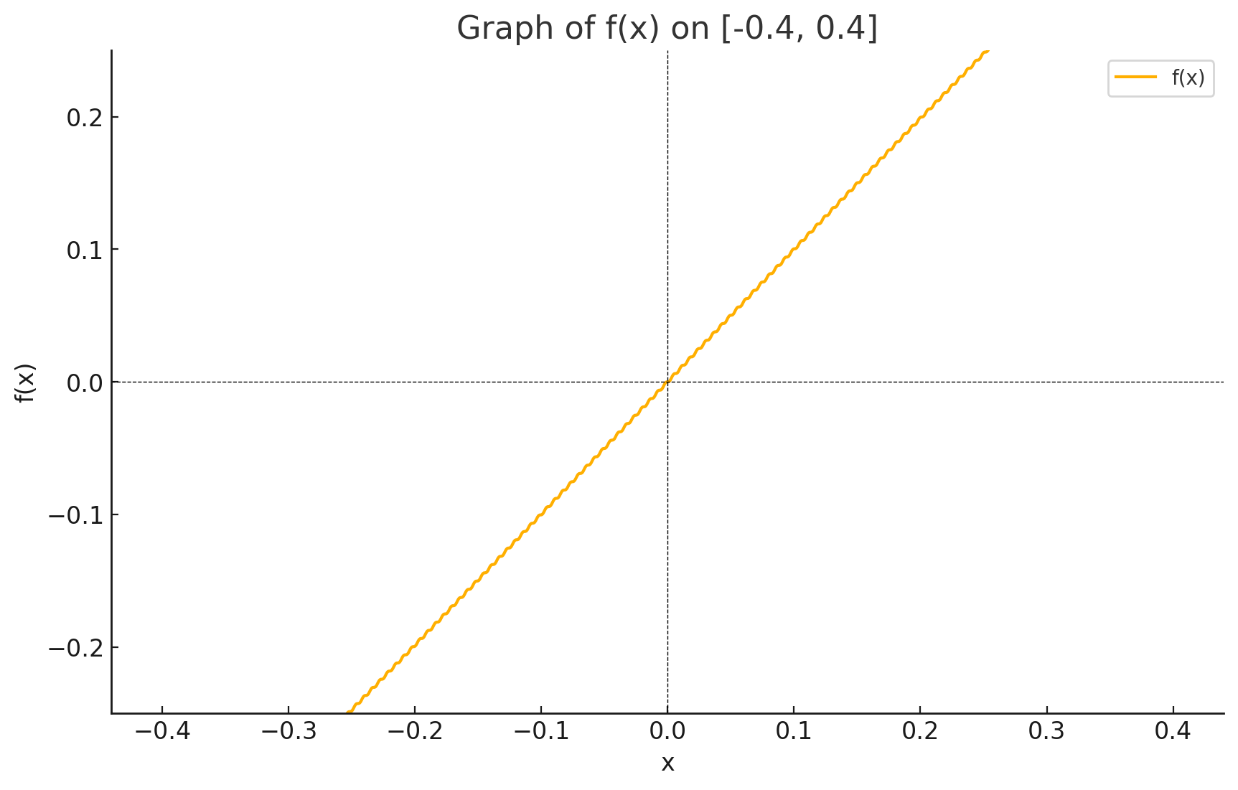

## (c) Zoom to [-0.008, 0.008] by [-0.005, 0.005]

Zooming further in reveals that the function becomes even smoother, with minimal oscillations around x = 0. The slope at x = 0 remains close to 0.

**Revised Estimate f'(0):** Further confirms that f'(0) = 0.

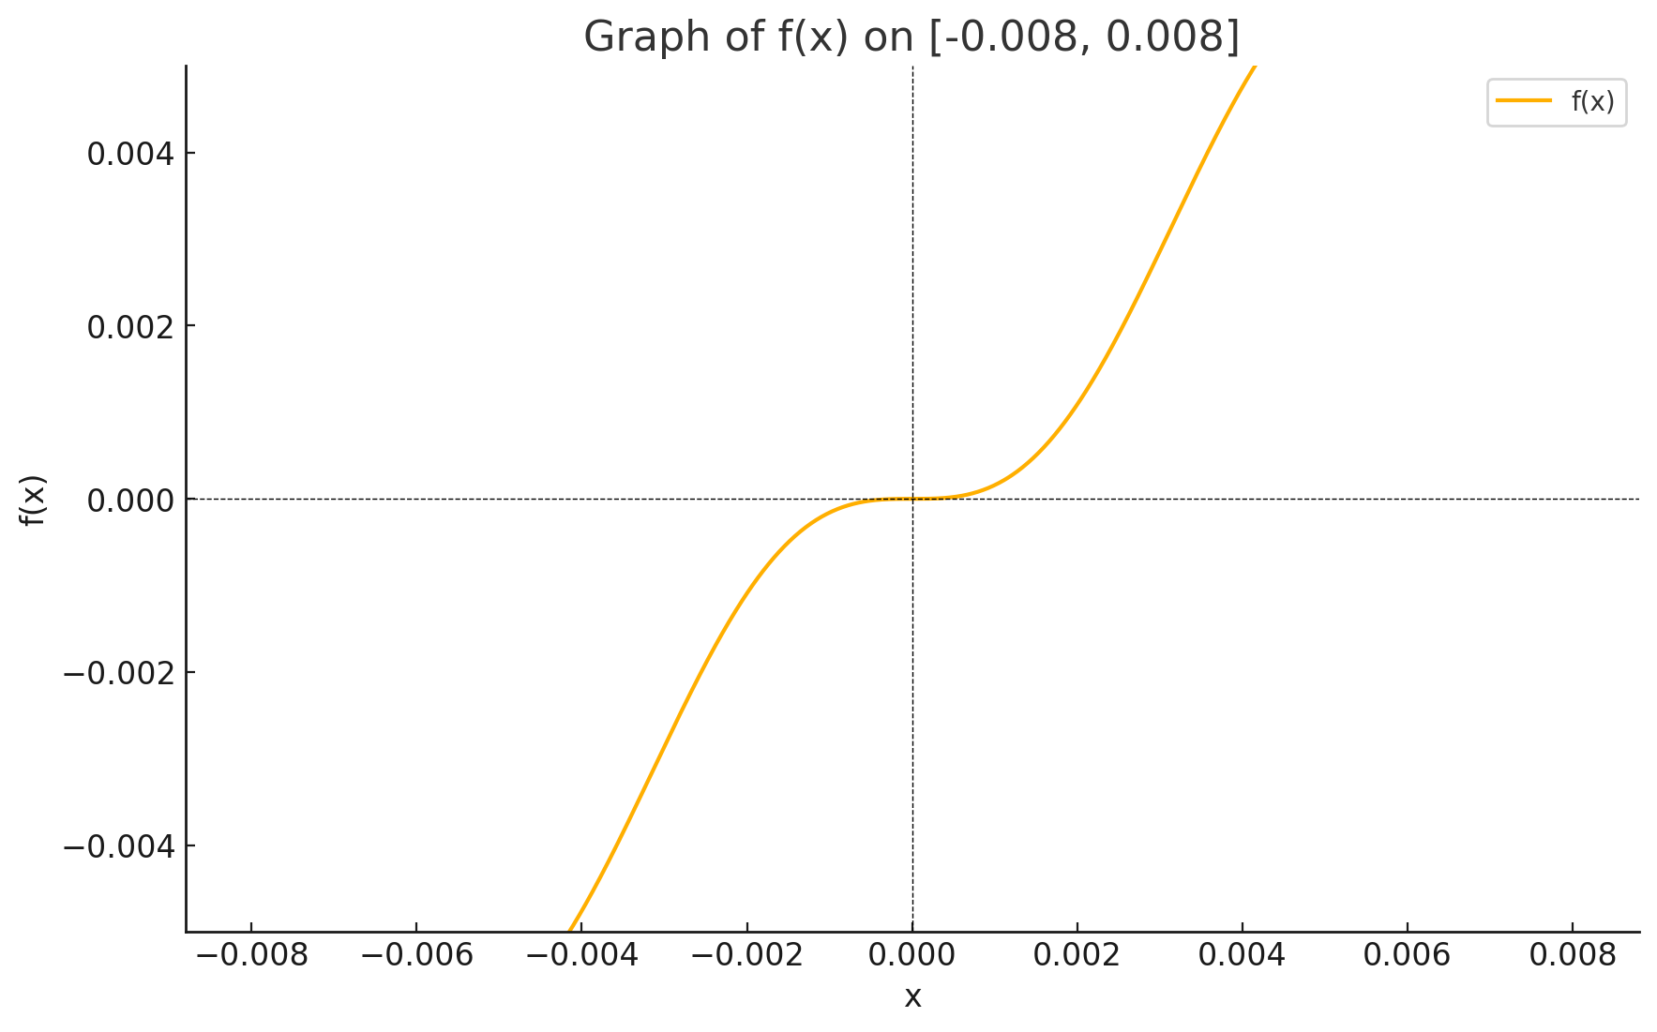

## Conclusion

1. The slope of f(x) at the origin is 0, supported by all zoomed-in views.

2. The oscillatory nature of the function diminishes near x = 0, leading to a clear estimate of f'(0) = 0.

# Problem 2

## Function Description

Consider the function defined by **f(x) = x + √|x|**, which includes a linear term and the square root of the absolute value of **x**. This combination affects the behavior and differentiability of the function significantly.

## Graphical Analysis

1. **Overall Graph (Full Range -2 to 2):** The graph shows a continuous increase, with a noticeable curve near the origin. This curve is primarily influenced by the square root component, illustrating the function's continuous nature throughout the domain.

2. **Detailed Analysis at Specific Points:**

- **Near \(x = -1\):** The function transitions smoothly through \(x = -1\) without abrupt changes in slope or direction, indicating linear behavior in this region.

- **At the Origin \(x = 0\):** A sharp curvature at the origin is observed, showing the significant impact of \(√|x|\). This results in a cusp at \(x = 0\), where the function is continuous but not differentiable due to the discontinuity in the derivative.

|  |  |
| --- | --- |
| **x** | **f(x)** |
| -2 | -0.58579 |
| -1.55556 | -0.30834 |
| -1.11111 | -0.05702 |
| -0.66667 | 0.14983 |
| -0.22222 | 0.249182 |
| 0.222222 | 0.693627 |
| 0.666667 | 1.483163 |
| 1.111111 | 2.165204 |
| 1.555556 | 2.802775 |
| 2 | 3.414214 |

## Differentiability

- At (x = -1): The function is differentiable at this point as it behaves linearly without discontinuity or sharp corners.

-At (x = 0): The function is not differentiable due to the presence of a cusp. The left-hand and right-hand derivatives do not match, reflecting the discontinuity caused by the square root of the absolute value.

## Conclusion

The function \(f(x) = x + √|x|\) exhibits specific characteristics at (x = 0\) that distinguish it from other points. The sharp turn and cusp at the origin, despite the overall continuity, highlight the critical aspect of this function: its lack of differentiability at zero.

# Problem 3

## Function Definition

The function f(x) is defined piecewise as follows:

f(x) = 0 if x ≤ 0

f(x) = (5 - x)/1 if 0 < x < 4

f(x) = 5 - x if x ≥ 4

## Part (a): Finding Derivatives

The left-hand and right-hand derivatives at specific points are calculated as follows:

f'₋(-4) = 0, since the function is constant (0) for x ≤ 0.

f'₊(4) = -1, as the function is defined by 5 - x for x ≥ 4, which has a constant derivative.

## Part (b): Sketching the Graph

The function transitions from a constant value at zero to a linear decline, and then continues linearly post the transition point at x = 4.

|  |  |
| --- | --- |
| **x** | **f(x)** |
| -2 | 0 |
| -1 | 0 |
| 0 | 0 |
| 0.1 | 4.9 |
| 1 | 4 |
| 2 | 3 |
| 3 | 2 |
| 3.9 | 1.1 |
| 4 | 1 |
| 5 | 0 |

## Part (c): Points of Discontinuity

The function exhibits a discontinuity at x = 0, where the function value jumps from 0 to 5, indicating a piecewise definition change.

## Part (d): Points of Non-differentiability

Non-differentiability occurs at x = 0 due to the discontinuity. The function is differentiable at x = 4 as the expression does not change at this point despite being a boundary in the piecewise definition.

## Conclusion

This analysis thoroughly covers the behavior of the piecewise-defined function at various critical points, demonstrating its characteristics in terms of continuity and differentiability.

**Problem 4**

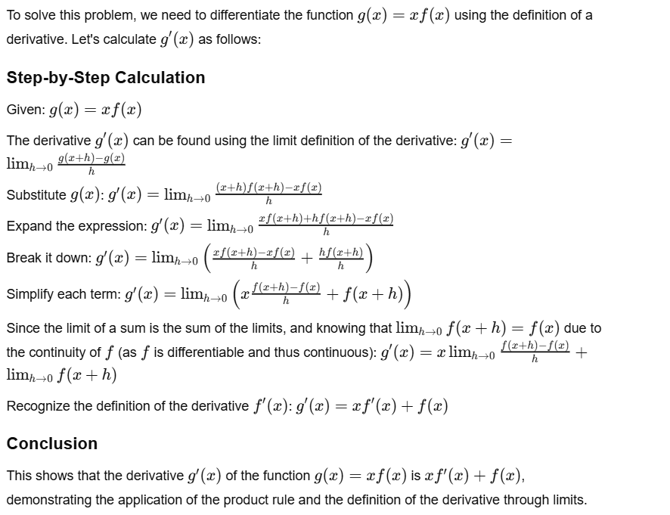

**Question 4**

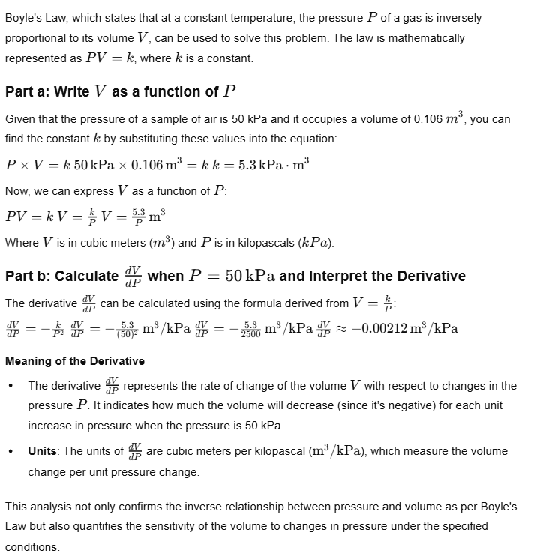

**Question 5**

# Tire Pressure and Tire Life Analysis

This document analyzes the relationship between tire pressure and tire life, highlighting how variations in pressure can impact tire longevity based on empirical data and mathematical modeling.

## Data Overview

Pressure (P) in lb/in²: 26, 28, 31, 35, 38, 42, 45

Tire Life (L) in thousands of miles: 50, 66, 78, 81, 74, 70, 59

## Quadratic Model for Tire Life

A quadratic model was developed to fit the relationship between tire pressure and tire life, expressed in the form \(L = aP^2 + bP + c\).

The derived coefficients from the quadratic regression are:

a = -0.2754, b = 19.7485, c = -273.5523

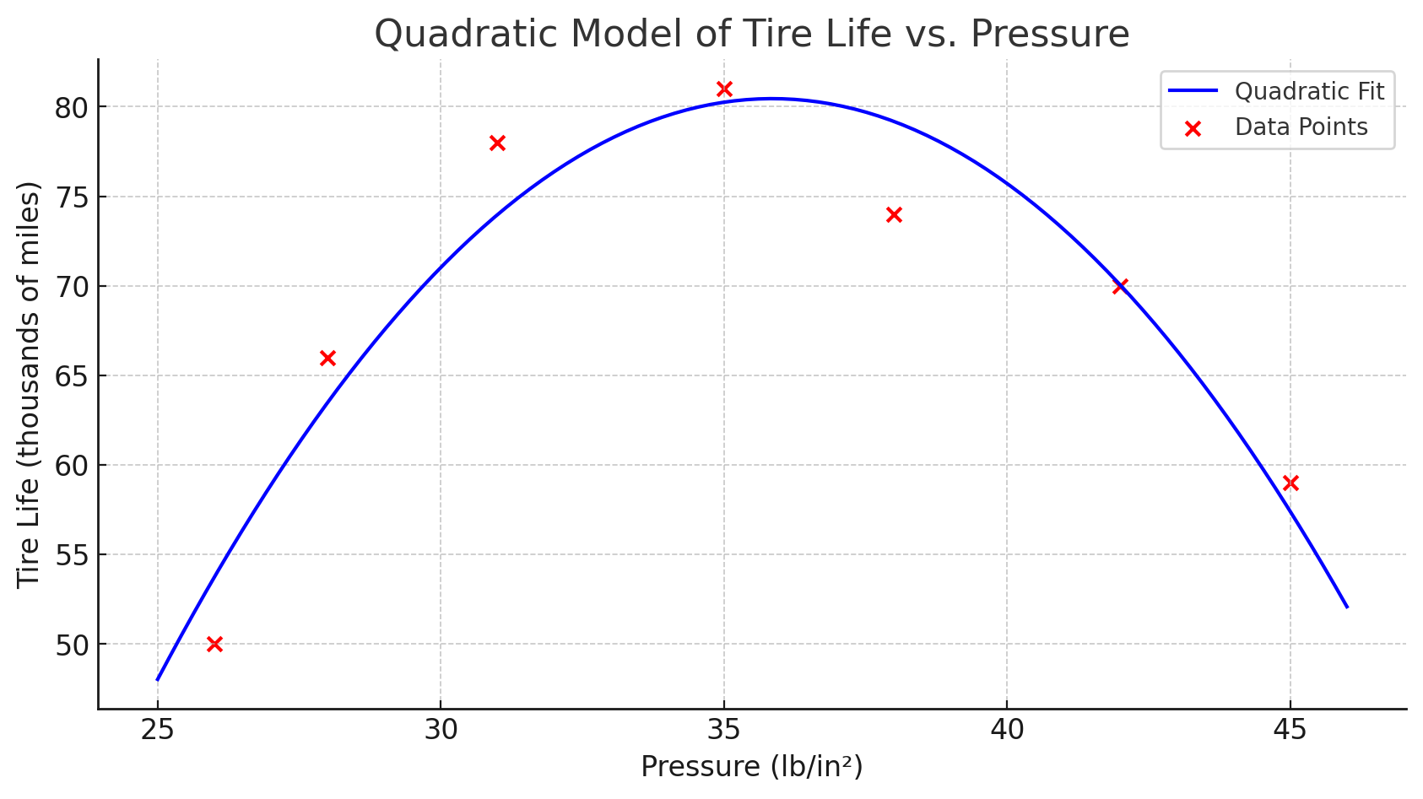

## Derivative Calculations

The rate of change of tire life with respect to tire pressure was calculated at specific pressures:

At \(P = 30\) lb/in²: 3.2229 thousands of miles per lb/in²

At \(P = 40\) lb/in²: -2.2857 thousands of miles per lb/in²

## Interpretation of the Derivatives

The derivative's positive value at \(P = 30\) suggests that a slight increase in pressure improves tire life, whereas the negative value at \(P = 40\) indicates that an increase in pressure reduces tire life.

## Conclusion

The analysis suggests there is an optimal tire pressure that maximizes tire life. Exceeding this pressure can lead to decreased tire longevity, underscoring the importance of maintaining appropriate tire inflation.